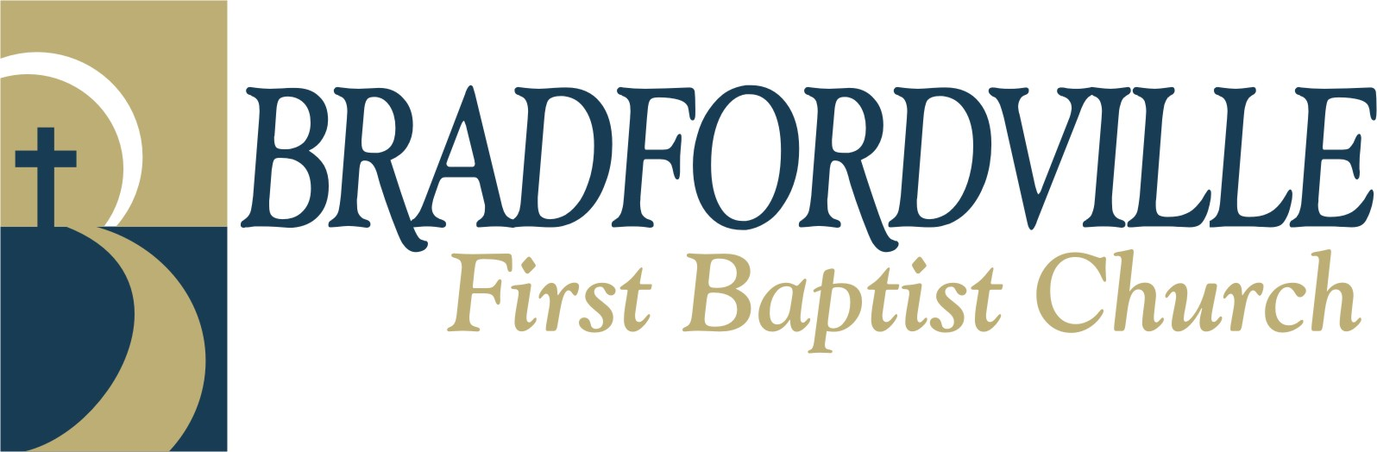

November 7, 2011

To Whom It May Concern:

It is my privilege to offer my personal recommendation for the ministry of Dr. Freddy Davis. Recently, Dr. Davis led our church in an insightful and inspirational study in Christian Worldview. Introducing the emphasis on a Sunday morning with an effective sermon from Ephesians 4, he then led three seminars in consecutive Wednesday nights. Covering a wealth of material in three relatively short sessions, he demonstrated his mastery of the subject.

Having authored a number of resource materials on the subject, he is able to communicate through the written word as well as the spoken word. His books, notebooks, and other resources are well written and prepared for the lay person or the scholar.

His teaching style is warm and engaging. The subject matter can be challenging but he is able to present the information with an understanding of his audience. Our people were encouraged to ask questions and participate in dialogue. A number of them not only purchased resources but continue to talk about the issues.

His breadth of experience and knowledge has also prepared him to approach many other topics and minister in a variety of settings. Freddy can be of great service to the local church or other organizations whether he is leading a prayer retreat, teaching on the great themes of the faith, or preaching in revival or spiritual renewal emphases. As a pastor, missionary, speaker, author, or consultant, Dr. Davis understands the culture we confront with the Gospel.

I encourage you to consider Freddy Davis when you are planning future events. I would be glad to respond to any questions you might have.

Respectfully,
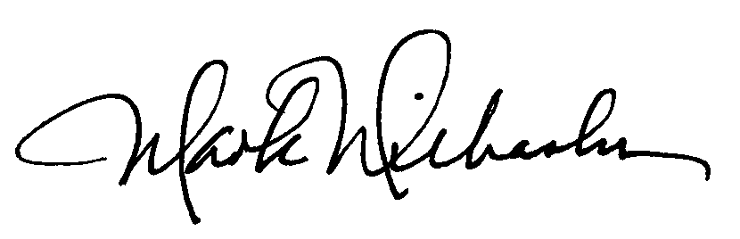

Mark O. Wilbanks, DEdMin
Senior Pastor

6494 Thomasville Road ~ Tallahassee Florida 32312 ~ 850.893.0893 ~ www.b-fbc.org

